IJC 437 Introduction to Data Science 2025-2026

Air Quality Dynamics in Sheffield and Hull: A Data Science Approach to Environmental Analysis

Student Registration Number: 250124882

Word count: 2002

January 9, 2026



Abstract
Air quality depends on both local emissions and larger atmospheric processes, which create different pollution patterns in each city. This study looks at air quality in Sheffield and Hull from 2023 to 2025, using exploratory data analysis to compare how NO₂, O₃, PM₂.₅, and PM₁₀ change over time in these two cities. The research uses open-source hourly monitoring data, which were cleaned and grouped into daily, monthly, and seasonal sets. Methods such as Locally Estimated Scatterplot Smoothing (LOESS), Seasonal Trend Decomposition using LOESS (STL), and correlation analysis were used to examine short-term changes, seasonal cycles, and long-term trends.
The results show that Sheffield has higher levels of NO₂ and PM₂.₅, which matches its heavy traffic emissions. Hull, on the other hand, has higher PM₁₀ and O₃ levels, likely due to its industrial and coastal location. Both cities have clear seasonal patterns; traffic-related pollutants peak in winter, while ozone peaks in spring and summer. Over time, NO₂ levels have declined, and O₃ levels have increased, likely due to changes in emissions. This study focuses on understanding and comparing these patterns over different time periods, rather than making predictions.

Chapter 1

Introduction

1.1 Background and Context
Air pollution remains a major environmental and public health concern in the United Kingdom, contributing to significant illness and premature mortality each year (OHID, 2022). Pollutants such as nitrogen dioxide (NO₂), ozone (O₃), and particulate matter (PM₂.₅ and PM₁₀) are strongly associated with cardiovascular and respiratory disease, making them a central focus of national clean air strategies (DEFRA, 2023). Despite long-term efforts to reduce emissions, air quality still varies across cities. These differences are influenced by local emission sources, urban layout, geography, and weather conditions.
Sheffield and Hull provide a useful comparative case. Sheffield is an inland, densely populated city where air quality is strongly influenced by road traffic and residual industrial activity (Sheffield City Council, 2010). Hull, in contrast, is a coastal port city affected by maritime transport, petrochemical industries, and enhanced atmospheric dispersion (Hull City Council, 2023). These contrasting environments make the two cities suitable case studies for examining how pollution behaves across different settings and seasons. The growing availability of monitoring data now allows these patterns to be explored in greater detail than was previously possible.

1.2 Literature Review
Previous research shows that pollutant behaviour is shaped by interactions between emission sources and atmospheric processes (Gibson et al., 2024). Seasonal effects are especially pronounced, with winter conditions often leading to elevated NO₂ and particulate matter concentrations due to reduced dispersion and increased combustion, while spring and summer sunlight promote photochemical ozone formation (Carslaw & Beevers, 2005; Monks et al., 2015).
Other studies find that inland and coastal cities have different pollution patterns. Sicard et al. (2020) found that coastal areas usually have lower NO₂ but higher ozone levels due to better airflow and different chemical reactions. DEFRA (2023) also reports that cities with lots of traffic have higher NO₂ and PM₂.₅, while industrial and coastal areas often see more PM₁₀ and O₃.
This study adds to previous research by using data science methods to see how these patterns appear in Sheffield and Hull. The goal is to understand how pollution changes over time, not to make predictions.

1.3 Aims and Research Questions

1.3.1 Aims
To analyse and compare the temporal behaviour of NO₂, O₃, PM₂.₅, and PM₁₀ in Sheffield and Hull from 2023 to 2025 using exploratory data analysis techniques.

1.3.2 Research Questions
- How do key air pollutants vary between Sheffield and Hull from 2023 to 2025?
- What daily, monthly, and seasonal patterns can be observed in pollutant levels across the two cities?

Chapter 2

Methodology

2.1 Data Description and Methods
Hourly air quality data for NO₂, PM₂.₅, PM₁₀, and O₃ were obtained from the OpenAQ API for Sheffield and Hull between 2023 and 2025. Data were cleaned and processed in RStudio and Microsoft Excel. Timestamps were standardised, duplicates removed, and missing values addressed before analysis. Hourly observations were aggregated into daily, monthly, and seasonal datasets, with seasons defined as Winter (Dec–Feb), Spring (Mar–May), Summer (Jun–Aug), and Autumn (Sep–Nov)
Exploratory Data Analysis (EDA) techniques were used to examine variability, seasonal differences, and relationships among pollutants. Because of high data noise, Locally Estimated Scatterplot Smoothing (LOESS) was applied to reveal medium-term trends. Seasonal Trend Decomposition using LOESS (STL) was applied to the monthly series to separate trend, seasonal, and remainder components. Correlation matrices were generated to assess relationships among pollutants and infer shared emission sources or chemical interactions.
RQ 1 is addressed by combining seasonal averages with LOESS and the long-term components extracted through STL decomposition. Together, these approaches enable comparison of overall pollutant levels between Sheffield and Hull and the identification of longer-term differences in their behaviour
RQ 2 is addressed using daily scatter plots, monthly summaries, seasonal groupings, the seasonal components from STL decomposition, and correlation analysis. This combination highlights short-term variability, recurring seasonal cycles, and the relationships between pollutants across the two cities.
All analyses used reproducible R scripts (see Appendix and GitHub profile). The study adopted a descriptive and exploratory approach because the research questions focused on interpretation rather than prediction.
  - Figure 2.1: Graphical Illustration of the Methodology
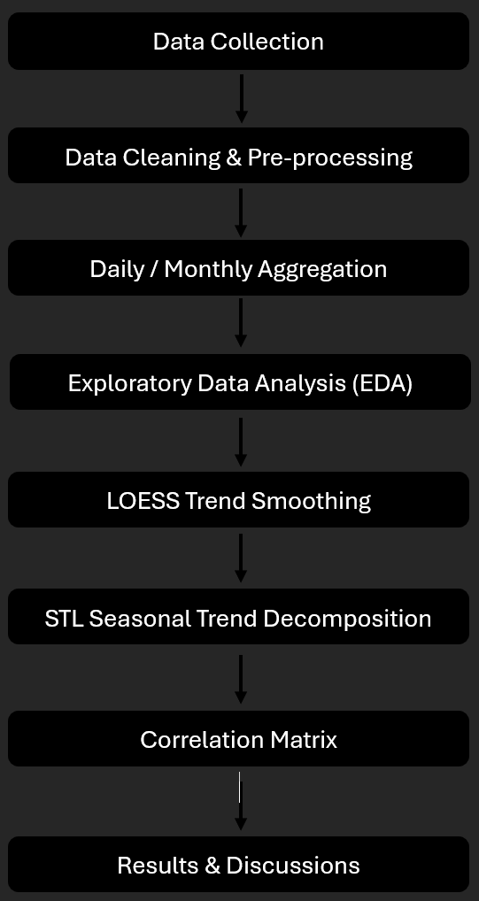

2.2 Analysis
The analysis used complementary steps to explore short-term variability and longer-term trends in pollutant behaviour across Sheffield and Hull. Initial analysis revealed substantial variation in the data, occasional outliers, and differences in average pollutant levels between the two cities.
  - Table 1.0: Daily Descriptive Statistics
City | Pollutant | N | Mean | Median | Standard Deviation | Interquartile Range
Hull | NO₂ | 328 | 16.97288 | 15.32124 | 9.943372 | 10.30348
Hull | PM_{2.5} | 328 | 7.559743 | 6.434783 | 3.839238 | 4.447908
Hull | PM₁₀ | 328 | 14.48975 | 13.36364 | 5.720636 | 6.6853
Hull | O₃ | 328 | 48.62344 | 48.7533 | 15.58634 | 17.73223
Sheffield | NO₂ | 328 | 15.16099 | 12.79724 | 10.0452 | 12.90284
Sheffield | PM₂₅ | 328 | 7.045114 | 6.043478 | 3.71254 | 5.152174
Sheffield | PM₁₀ | 328 | 12.02268 | 10.86957 | 5.300609 | 6.826087
Sheffield | O₃ | 328 | 46.45978 | 46.10501 | 16.2674 | 17.77408

To make temporal patterns easier to interpret, Locally Estimated Scatterplot Smoothing (LOESS) was applied to the daily time series, revealing medium-term changes that were difficult to discern in the raw data. Seasonal Trend Decomposition using LOESS (STL) was then used to decompose each pollutant into seasonal, trend, and residual components, enabling recurring seasonal cycles to be distinguished from longer-term trends.
Relationships between pollutants were examined using correlation matrices, which showed how particulate matter, nitrogen dioxide, and ozone interact within each city’s atmosphere. All analyses used reproducible R scripts (see Appendix and GitHub Profile). No predictive modelling was done, as the study focused on describing and interpreting observed patterns rather than predicting future concentrations.

Chapter 3

Results

3.1 Exploratory Data Analysis

  - Figure 3.1: Seasonal Average Bar Plot
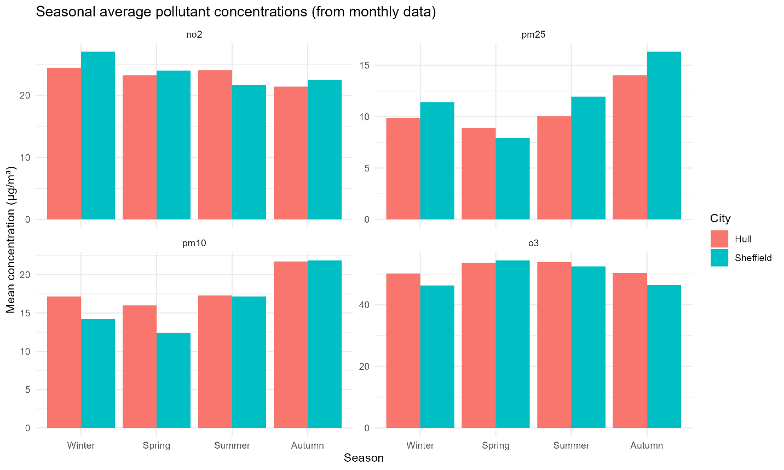

Figure 3.1 highlights clear patterns in both cities. NO₂ levels are highest in winter and lowest in summer, with Sheffield consistently showing higher values than Hull, likely due to greater traffic influence. PM₂.₅ and PM₁₀ also rise during colder months. Sheffield has higher PM₂.₅, while Hull has higher PM₁₀, reflecting differences in combustion and industrial sources. Ozone peaks in spring and summer, with Hull generally recording higher values, possibly due to reduced ozone titration.

  - Figure 3.2: Daily Average Scatter Plot
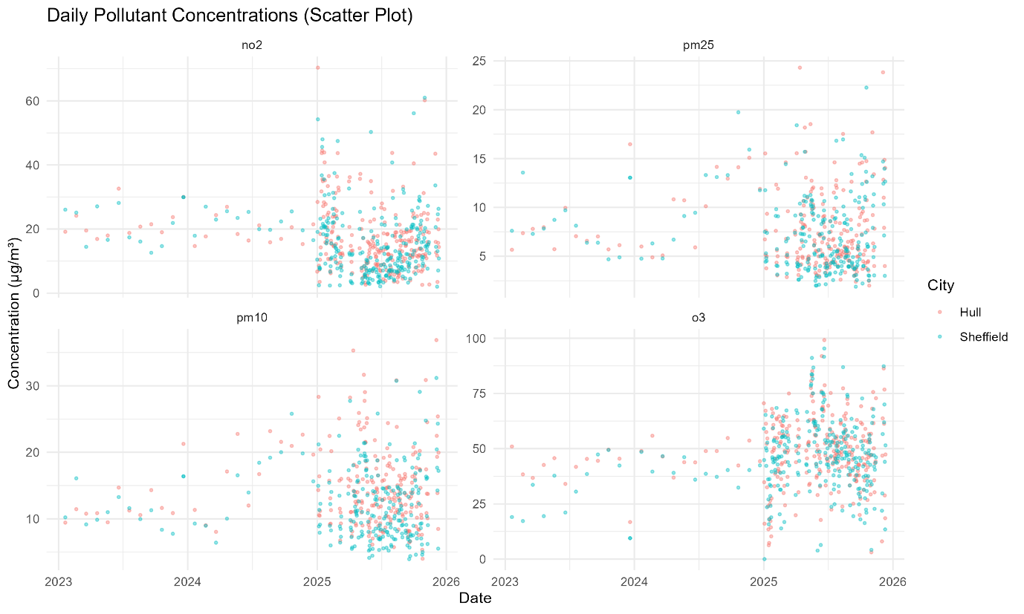

Figure 3.2 shows substantial short-term variability and occasional pollution spikes, particularly in 2025. Although both cities exhibit similar ranges of fluctuation, the density of observations makes it difficult to identify underlying trends from the raw data alone.

3.1.1 Locally Estimated Scatterplot Smoothing (LOESS)

  - Figure 3.3: LOESS Trend
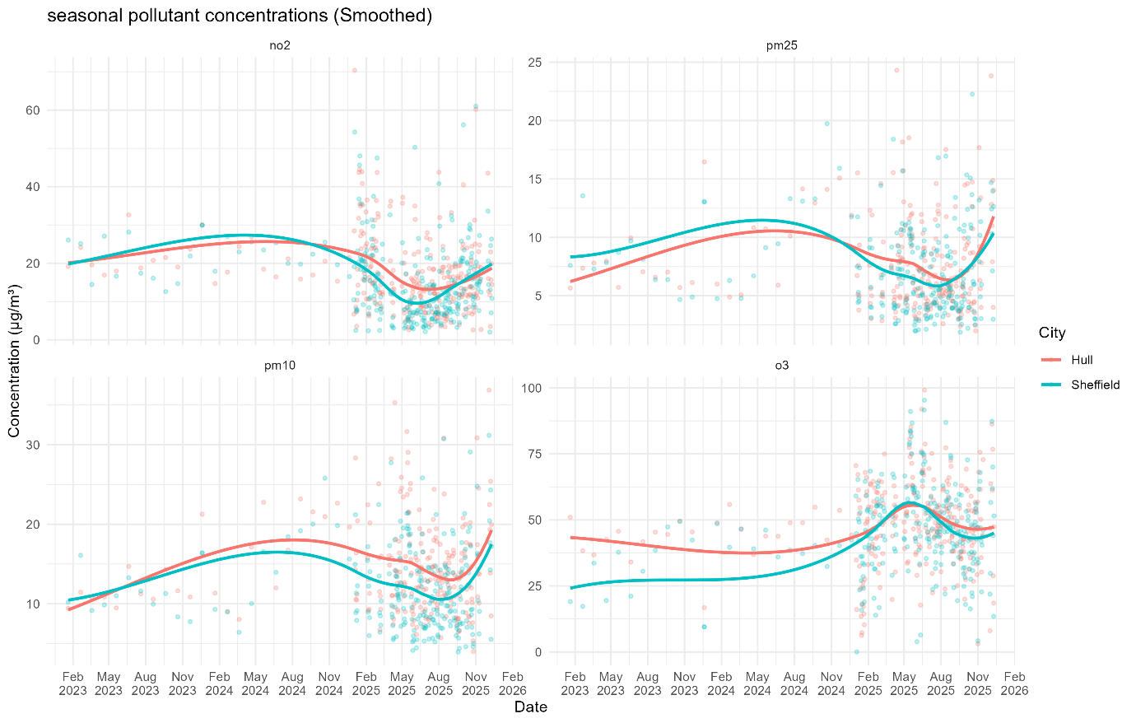

Figure 3.3 clarifies the temporal structure obscured in Figure 3.2. NO₂ concentrations decline from 2023 into late 2024, rise briefly in early 2025, and then decline again towards the end of the study period. PM₂.₅ and PM₁₀ show similar seasonal behaviour, with winter increases and summer declines. O₃ follows an opposing pattern, increasing during the warmer months and showing a gradual upward trend over time.
Compared with Figure 3.2, Figure 3.3 helps distinguish real trends from random daily fluctuations. The raw data are variable and erratic, especially in 2025, making it difficult to discern the direction of change. Smoothing provides a more precise representation of pollutant behaviour over time, confirming shared regional seasonal cycles while still emphasising differences in the emission profiles of Hull and Sheffield.

3.1.2 Seasonal Trend Decomposition using LOESS (STL)
  - Figure 3.4: STL Decomposition Hull PM₁₀
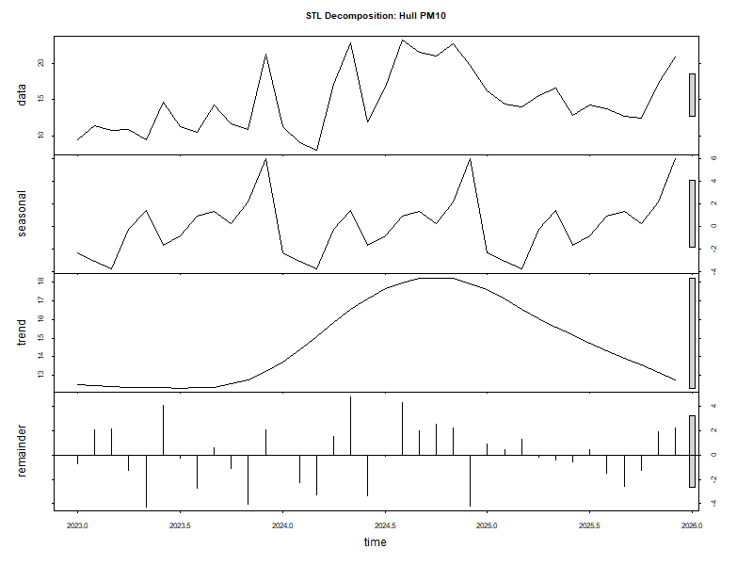

NO₂ and particulate matter demonstrate pronounced seasonal cycles, characterised by elevated concentrations in winter and lower levels in summer. Ozone shows peak concentrations during summer and a sustained upward trend, which aligns with reduced NO₂ driven ozone titration. The remaining components contribute minimally, indicating that seasonal and trend effects account for most of the observed variability rather than random fluctuations.

  - Figure 3.5: STL Decomposition Sheffield PM₁₀
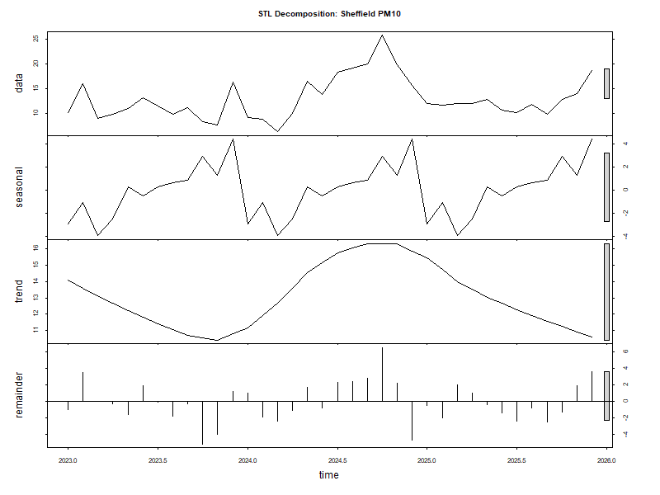

  - Figure 3.6: STL Decomposition Hull PM_{2.5}
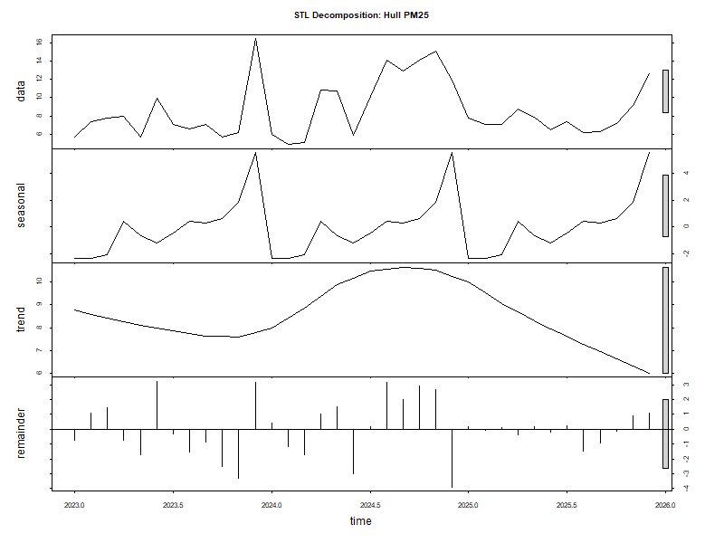

  - Figure 3.7: STL Decomposition Sheffield PM_{2.5}
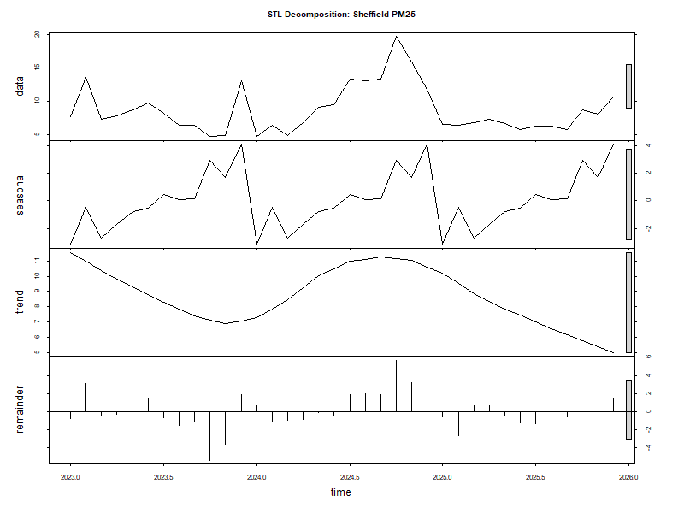

  - Figure 3.8: STL Decomposition Hull NO₂
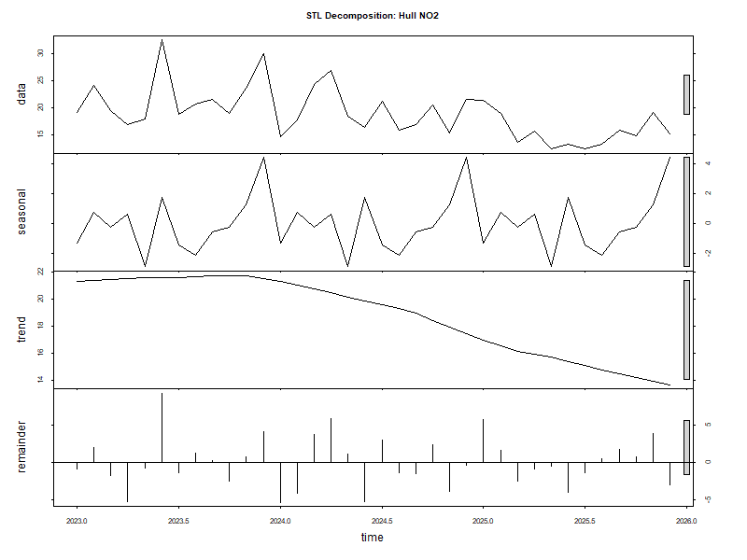

  - Figure 3.9: STL Decomposition Sheffield NO₂
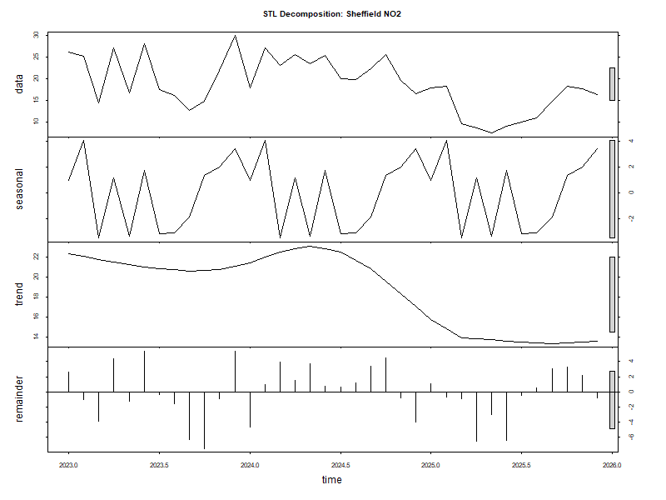

  - Figure 3.10: STL Decomposition Hull O₃
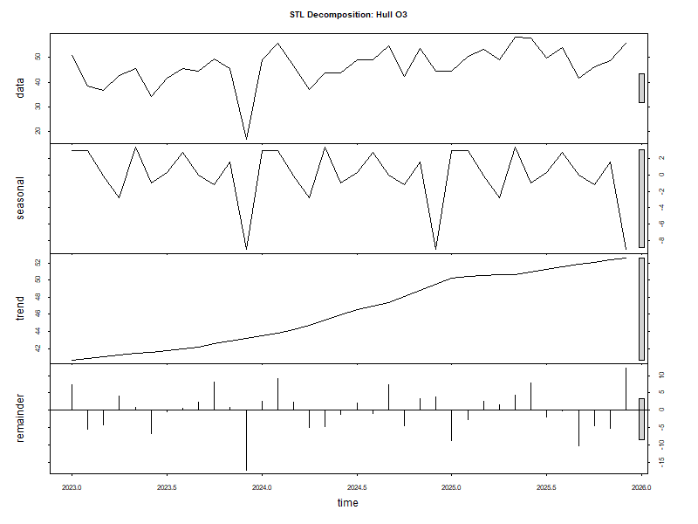

  - Figure 3.11: STL Decomposition Sheffield O₃
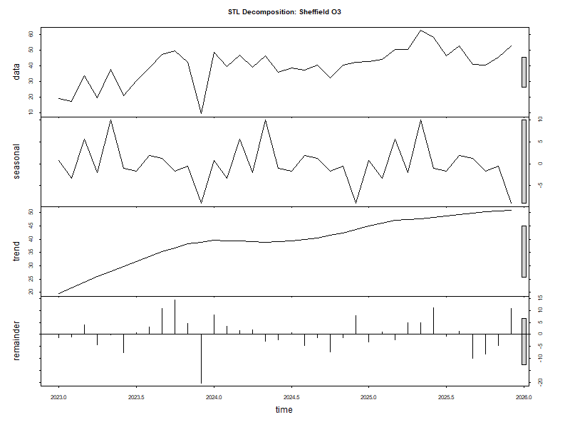

3.1.3 Correlation Matrix

  - Figure 3.12: Correlation Matrix Hull
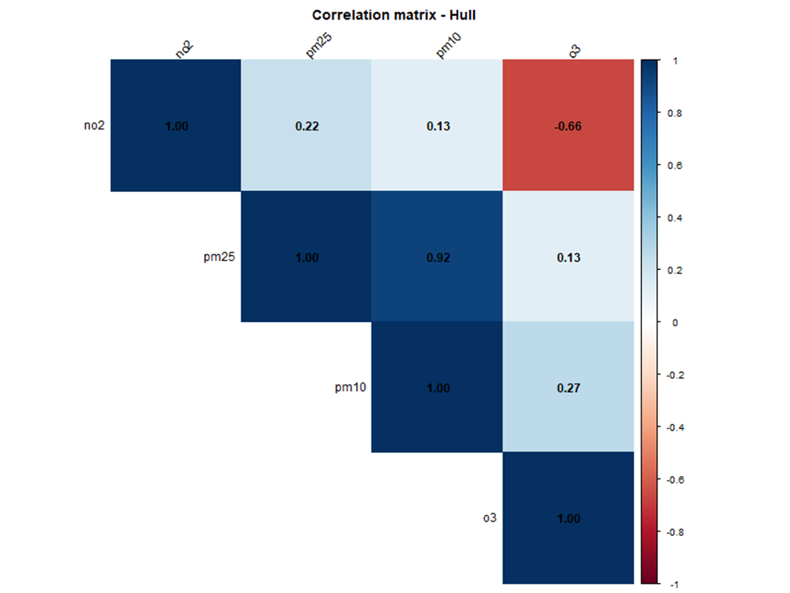

Both cities show strong positive correlations between PM₂.₅ and PM₁₀, suggesting shared sources or meteorological factors. In Sheffield, moderate positive correlations between NO₂ and particulates indicate traffic emissions. These correlations are weaker in Hull, likely due to more varied sources or greater coastal dispersion. Both cities also display a strong negative correlation between NO₂ and O₃, consistent with photochemical titration processes.

  - Figure 3.12: Correlation Matrix Sheffield
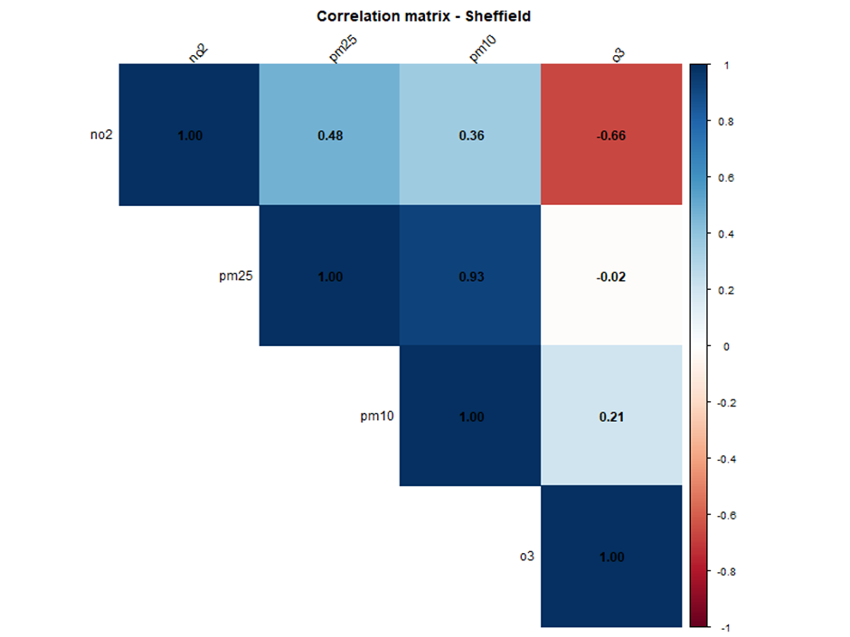

3.2 Discussion
LOESS and STL decomposition were essential for interpreting the data. These techniques separated trends from short-term noise and identified seasonal patterns. Correlation analysis supported existing chemical principles, especially the strong relationship between particulates and the inverse relationship between NO₂ and O₃.

3.2.1 Answering the Research Questions

3.2.1.1 How do key air pollutants vary between Sheffield and Hull from 2023 to 2025?

Overall, Sheffield consistently recorded higher NO₂ and PM₂.₅ concentrations, while Hull generally exhibited higher PM₁₀ and O₃ levels. These differences reflect contrasting emission profiles and environmental settings. Sheffield’s elevated NO₂ and PM₂.₅ are likely linked to higher traffic density and combustion sources, whereas Hull’s higher PM₁₀ and ozone appear influenced by industrial activity, maritime sources, and coastal atmospheric conditions. Although NO₂ declined in both cities over time, Sheffield remained consistently higher, whereas ozone gradually increased, with Hull maintaining higher levels throughout.

3.2.1.2 What daily, monthly, and seasonal patterns can be observed in pollutant levels across the two cities?
Daily pollutant concentrations display substantial short-term variability and occasional spikes in both cities, primarily influenced by meteorological conditions and transient events. At monthly and seasonal timescales, a more defined pattern is observed; concentrations of NO₂, PM₂.₅, and PM₁₀ reach their highest levels in winter and decrease during summer, reflecting increased emissions and reduced atmospheric dispersion in colder months. In contrast, ozone exhibits higher concentrations in spring and summer, attributable to intensified photochemical activity. STL decomposition shows that pronounced seasonal cycles account for much of the observed variability. Correlation analysis reveals consistent interrelationships among pollutants, particularly a strong negative association between NO₂ and O₃.

3.2.2 Relation to Existing Research
These results are consistent with existing UK air quality research. Sheffield’s higher NO₂ and PM₂.₅ levels reflect findings that traffic-dominated inland cities experience more combustion-related pollutants (Carslaw & Beevers, 2005; DEFRA, 2023).
In contrast, Hull’s higher PM₁₀ and ozone levels reflect patterns commonly reported in coastal and industrial cities, where enhanced atmospheric mixing and reduced NO₂ titration influence pollutant behaviour (Monks et al., 2015; Sicard et al., 2020).
The distinct seasonal patterns in both cities align with known atmospheric processes, with winter peaks in NO₂ and particulate matter, and spring-to-summer peaks in ozone driven by photochemical activity (WHO, 2021). The decline in NO₂ and rise in ozone further support evidence that changes in nitrogen oxide emissions can alter ozone chemistry. Overall, the findings reinforce existing literature and highlight the role of environmental context in shaping pollution patterns.

Chapter 4

GitHub
As part of the project workflow, all R scripts, datasets, and visualisation figures were uploaded to a GitHub repository. The repository was organised for easy navigation, with separate sections for the IJC437 and IJC445 project pages, and a code directory containing well-commented R scripts. Clear instructions for running the analysis were also included.
GitHub repository: https://github.com/tanure1999/Air-Quality-Analysis-Sheffield-Hull-2023-2025
  - Figure 4.1: GitHub Repo Page


Chapter 5

Conclusion
This study reveals clear seasonal patterns, distinct city-level pollution profiles, and consistent relationships among key pollutants. Sheffield consistently recorded higher NO₂ and PM₂.₅ concentrations, reflecting traffic and combustion emissions, while Hull recorded higher PM₁₀ and slightly elevated ozone levels, consistent with industrial activity and coastal dispersion.
Both cities exhibited strong seasonality, with winter peaks in NO₂ and particulate matter and summer peaks in ozone. Longer-term trends indicate declining NO₂ alongside a gradual rise in ozone, aligning with established atmospheric chemistry and changing emission policies.
The analysis was limited by uneven data coverage, reliance on a single monitoring station, and the potential masking of short-term pollution patterns through aggregation. Future work could integrate meteorological variables, include additional monitoring sites, and extend the analysis using predictive approaches.
Overall, the study demonstrates how combining statistical analysis with domain knowledge supports the interpretation of air quality data.

Reference
Carslaw, D. C., & Beevers, S. D. (2005). Estimations of road vehicle primary NO₂ exhaust emission fractions using monitoring data in London. Atmospheric Environment, 39(1), 167–177. https://doi.org/10.1016/j.atmosenv.2004.08.053
Cairo, A. (2016). The truthful art: Data, charts, and maps for communication. New Riders.
Cleveland, W. S., & McGill, R. (1984). Graphical perception: Theory, experimentation, and application to the development of graphical methods. Journal of the American Statistical Association, 79(387), 531–554. https://doi.org/10.1126/science.229.4716.828
Department for Environment, Food & Rural Affairs (DEFRA). (2023). Air quality statistics in the UK. UK Government. https://www.gov.uk/government/statistics/air-quality-statistics
Few, S. (2012). Show me the numbers: Designing tables and graphs to enlighten (2nd ed.). Analytics Press.
Hull City Council. (2023). Air quality annual status report (ASR).
Monks, P. S., Archibald, A. T., Colette, A., Cooper, O., Coyle, M., Derwent, R., Fowler, D., Granier, C., Law, K. S., Mills, G. E., Stevenson, D. S., Tarasova, O., Thouret, V., von Schneidemesser, E., Sommariva, R., Wild, O., & Williams, M. L. (2015). Tropospheric ozone and its precursors from the urban to the global scale from air quality to short-lived climate forcer. Atmospheric Chemistry and Physics, 15(15), 8889–8973. https://doi.org/10.5194/acp-15-8889-2015
OpenAQ. (2024). OpenAQ platform: Open air quality data. https://openaq.org

Sheffield City Council. (2010). Air quality in Sheffield.
https://www.sheffield.gov.uk/pollution-nuisance/air-quality
Sicard, P., De Marco, A., Agathokleous, E., Feng, Z., Xu, X., Paoletti, E., & Calatayud, V. (2020). Amplified ozone pollution in cities during the COVID-19 lockdown. Science of the Total Environment, 735, 139542. https://doi.org/10.1016/j.scitotenv.2020.139542
Ware, C. (2013). Information visualisation: Perception for design (3rd ed.). Morgan Kaufmann.
World Health Organisation (WHO). (2021). WHO global air quality guidelines: Particulate matter (PM₂.₅ and PM₁₀), ozone, nitrogen dioxide, sulphur dioxide and carbon monoxide.
https://www.who.int/publications/i/item/9789240034228
World Wide Web Consortium (W3C). (2018). Web Content Accessibility Guidelines (WCAG) 2.1. https://www.w3.org/TR/WCAG21/

Appendix
  - 7.1: Install & Load Packages
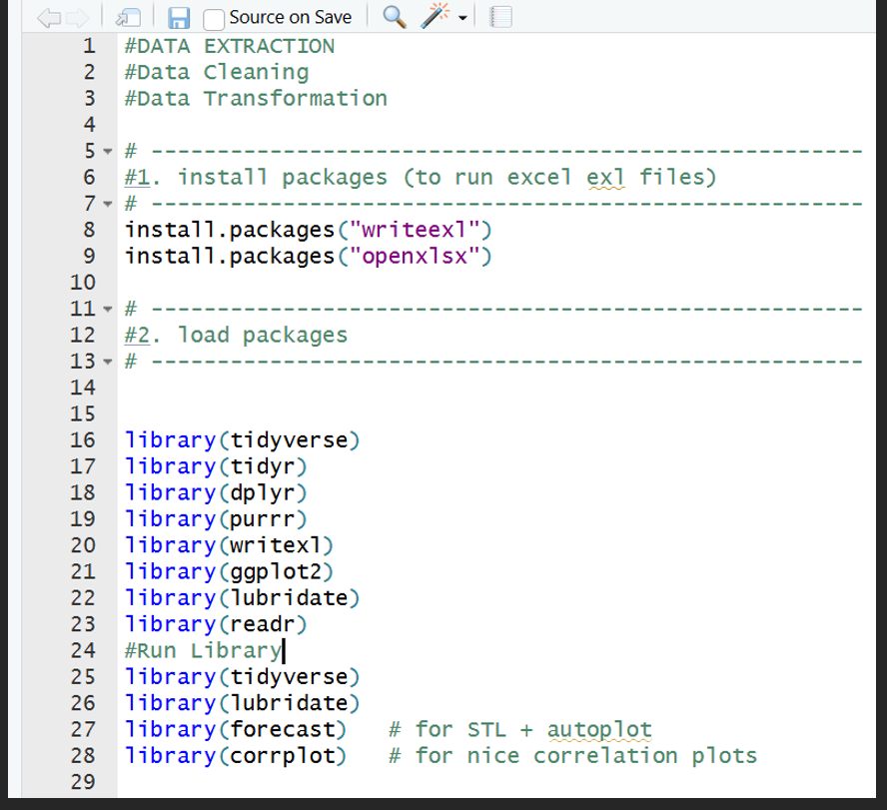

  - 7.2: Quick Plot Test After Data Cleaning
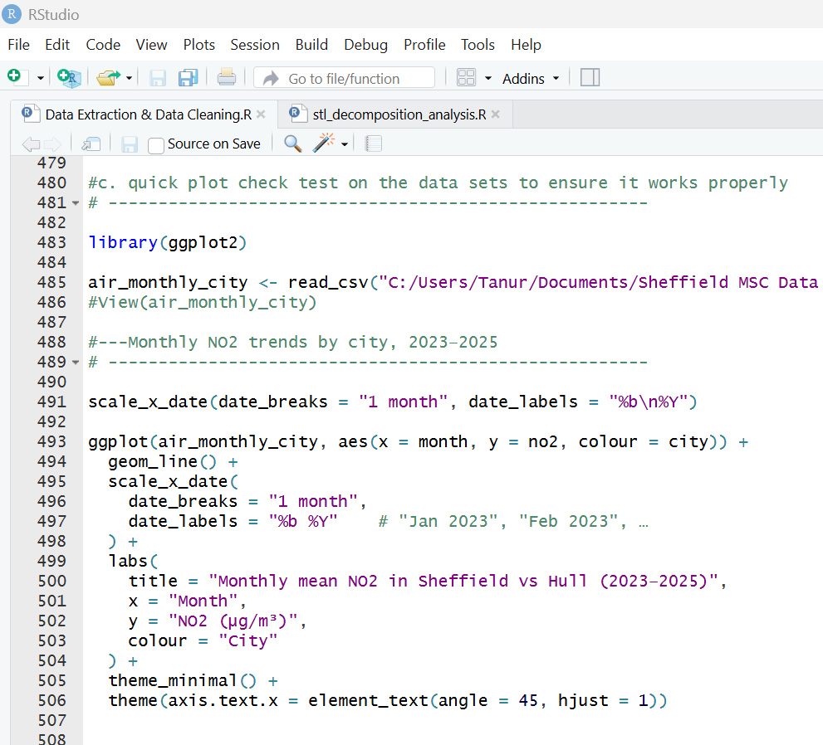
  - 7.3: CSV(not all) Files after Data Extraction & Cleaning
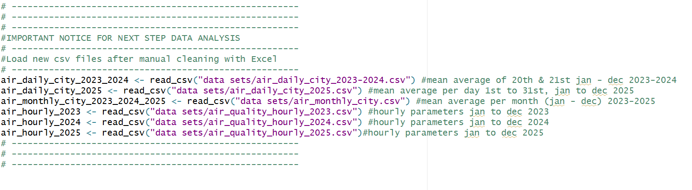

  - FIG 7.4: Load Aggregated CSV Files
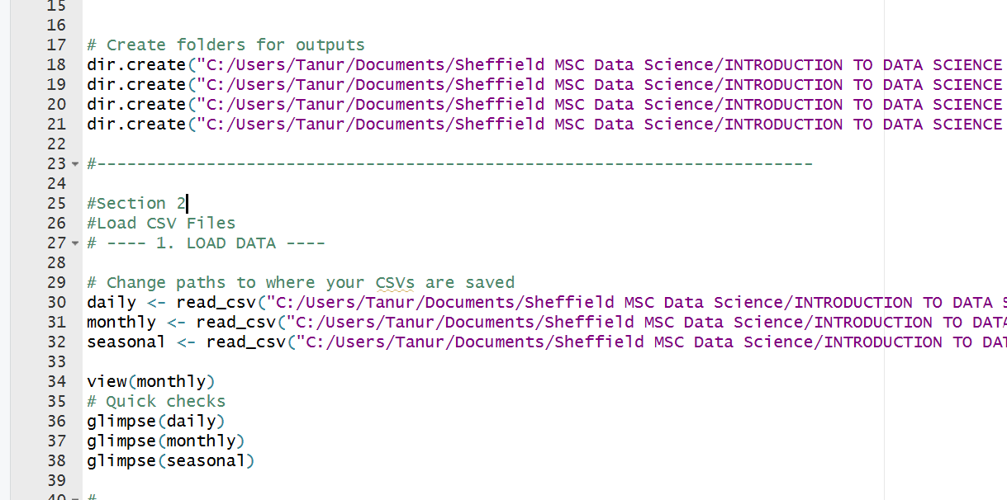
  - FIG 7.5: Standardising Date Columns
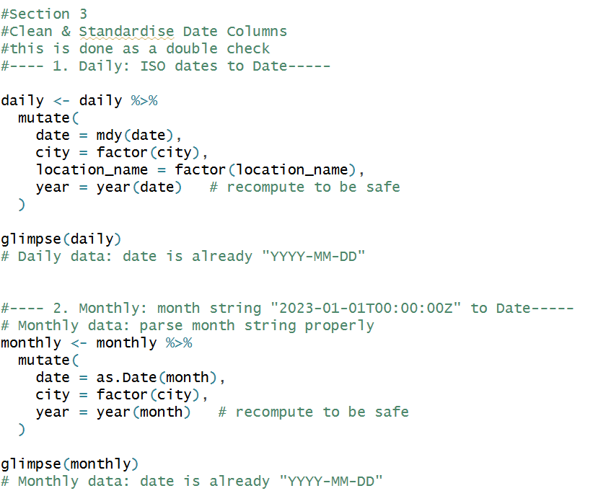

  - FIG 7.6: Seasonal Bar Plot
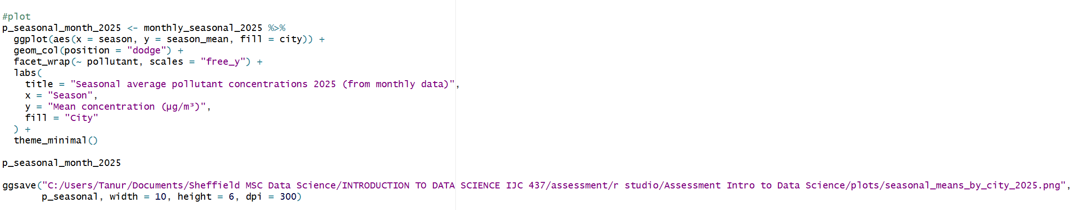
FIG 7.7: Scatter Plot
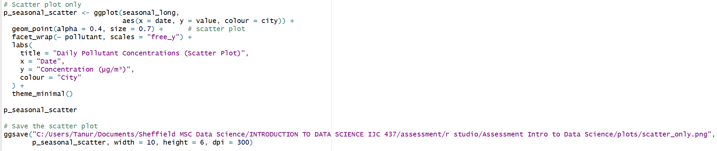
  - FIG 7.8: LOESS Plot
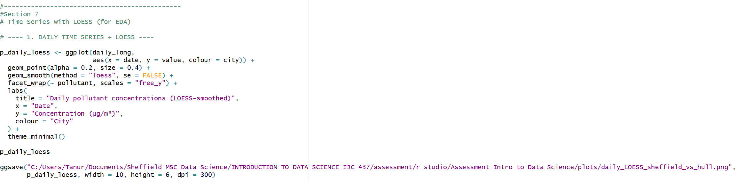

  - FIG 7.9: STL Decomposition using LOESS
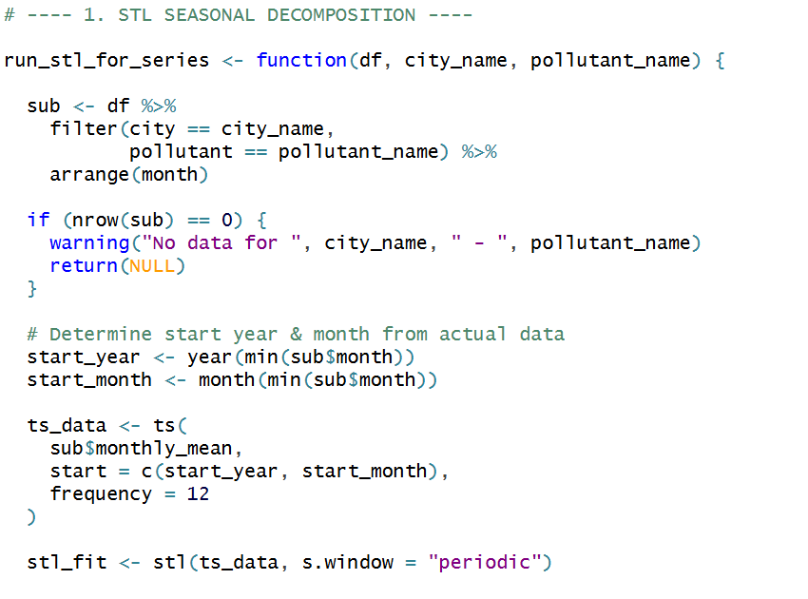
  - FIG 7.10: STL Decomposition using LOESS (ctd)
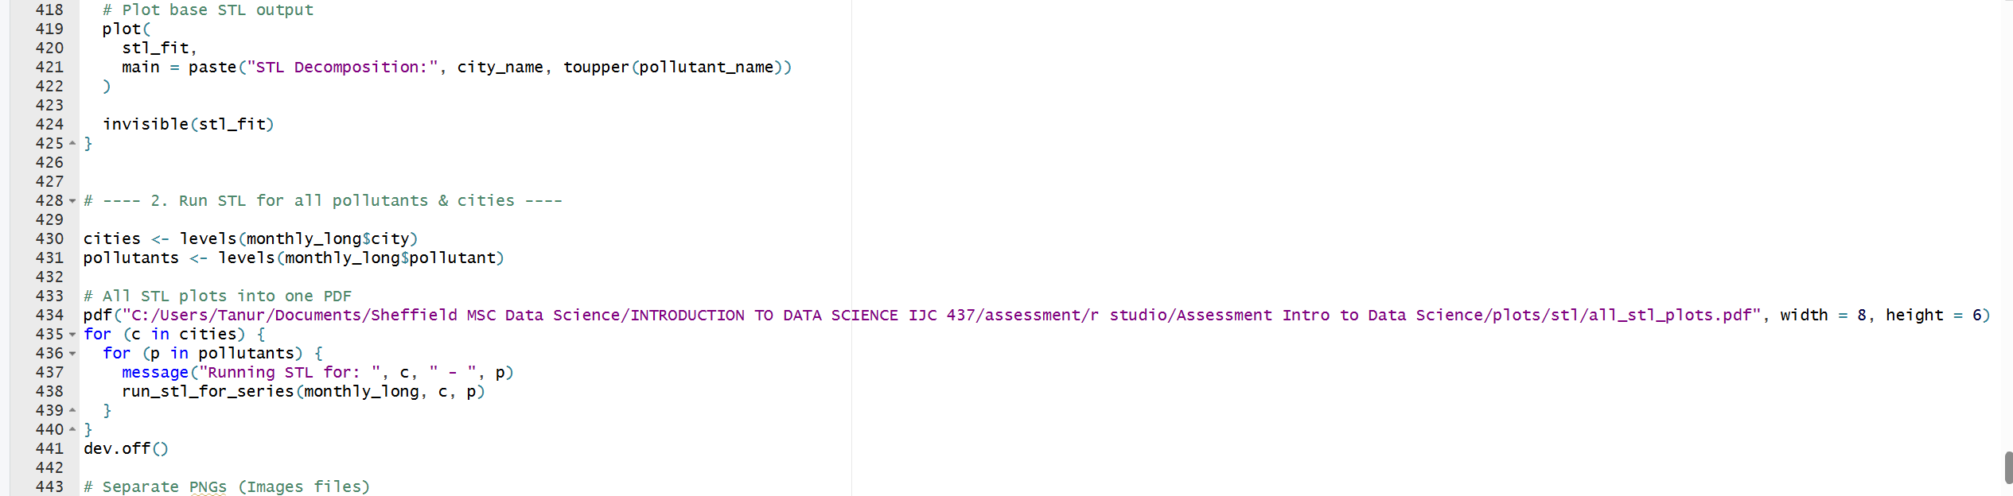

  - FIG 7.11: Correlation Matrix Plot
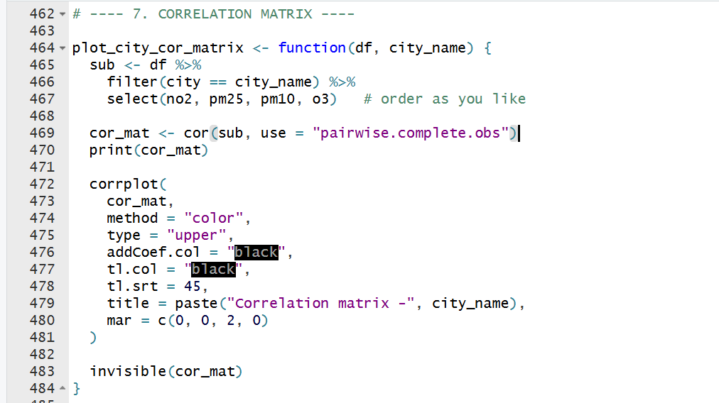
  - FIG 7.12: Correlation Matrix Plot (ctd)